Technical and Design Document

Low Level Design

High Level Design

<https://www.figma.com/design/7dG6xmXM4ogDXIUWRLiUP5/Skin-Disease-App?node-id=0-1&node-type=canvas&t=LyAE76WCA1h6Wybe-0>

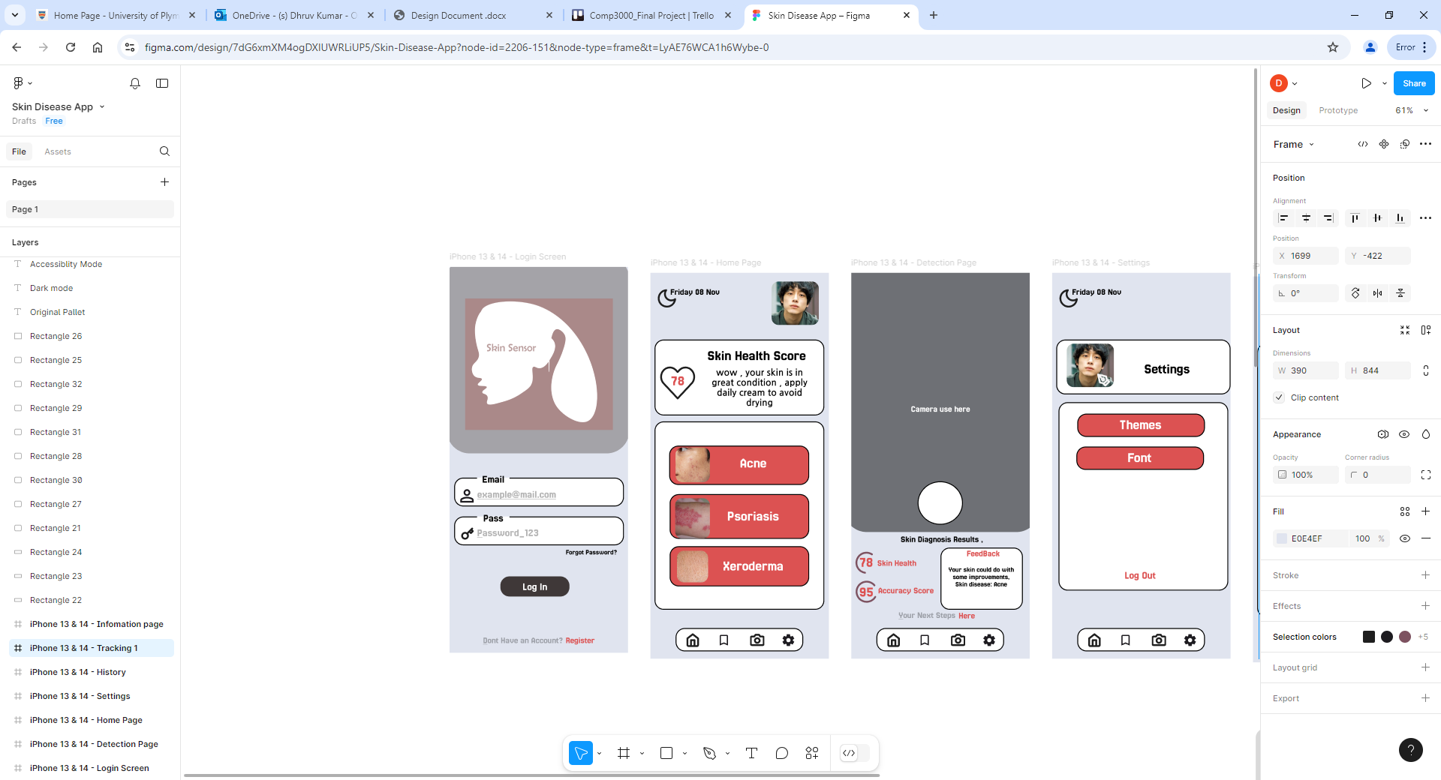

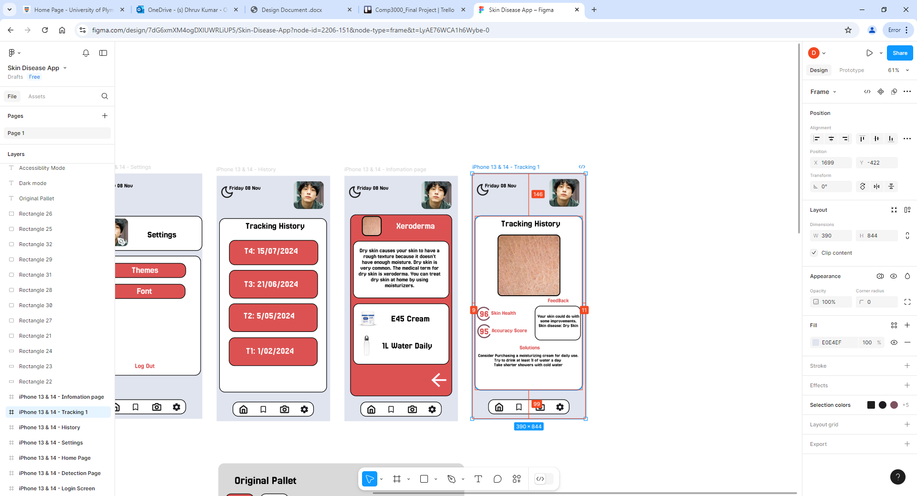

Above is the proposed designed for the application, the design stays consistent throughout the app allowing ease of use for the user. The colour scheme consists of three colour pallet as to not overload the user with a multitude of colours. Based on research of other skin disease applications, I had found that most applications were overloaded for information creating a disappealing user experience. Taking from this i decided to have a simpler design where there would be multiple different widgets/buttons that will sperate information to avoid overloading. Other areas where there could be improvement would be the colour contrast as other applications kept to minimal colour contrast between the text and background leading to reading issues. Considering this, for the text i made sure that it stands out from the background to avoid reading issues.

Accessibility

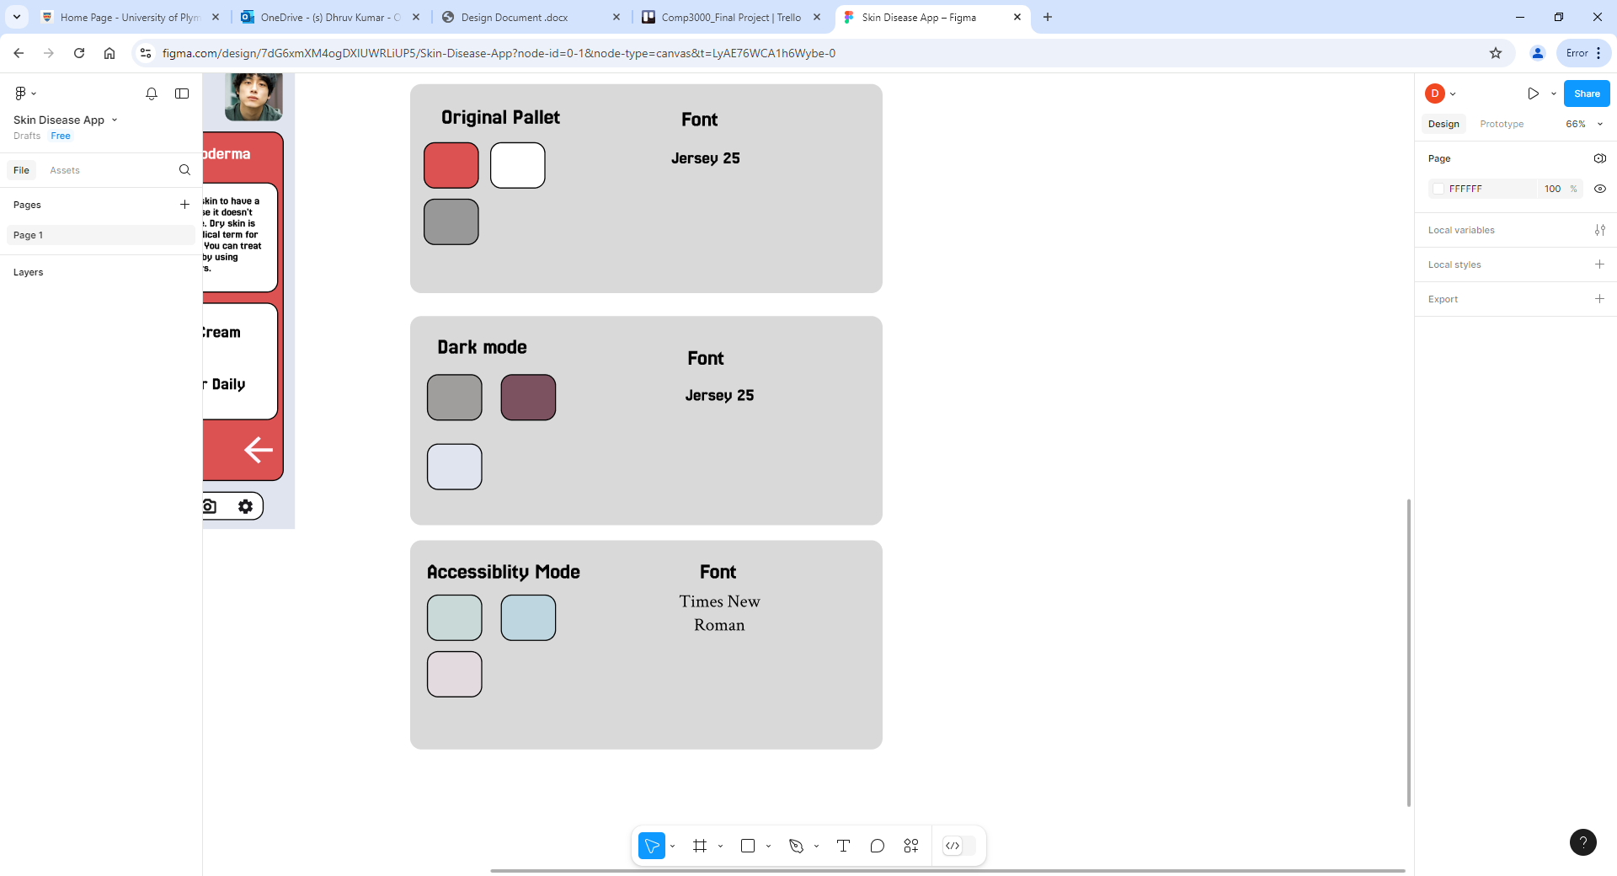

Ethical and Legal Considerations

Informed user Consent: As the Application will hold the user's diagnosis's and take images using the phone camera, user consent will be needed as to not breach and privacy laws.

Personal Data Protection: User Data may need to be removed or encrypted, this can be in cases of removal of medical information on datasets or removing and identifying features on taken images.

Correct Diagnosis: As the Application will be using Ai to detect for any skin related issues the Ai must give out the correct diagnosis to avoid potential misinformation and legal issues.

Disability Support: The application needs to ensure that impaired or people with disabilities can use the App. This could be done be incorporating features such as colour-blind mode or voice commands.

Language Accessibility: As the App is also targeted internationally, for future updates language options will need to be considered for areas with differences in health and skin disease prevalence.

Dataset use: As the application will be using an online dataset from a reliable source, the dataset may have a use agreement, considering this the application and AI will need to restrict so that there are no breaches in the use agreement which can lead to legal action.

UML Diagrams

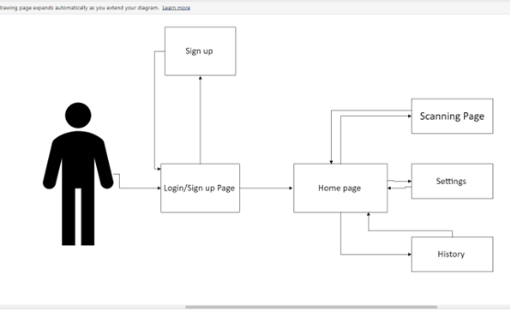

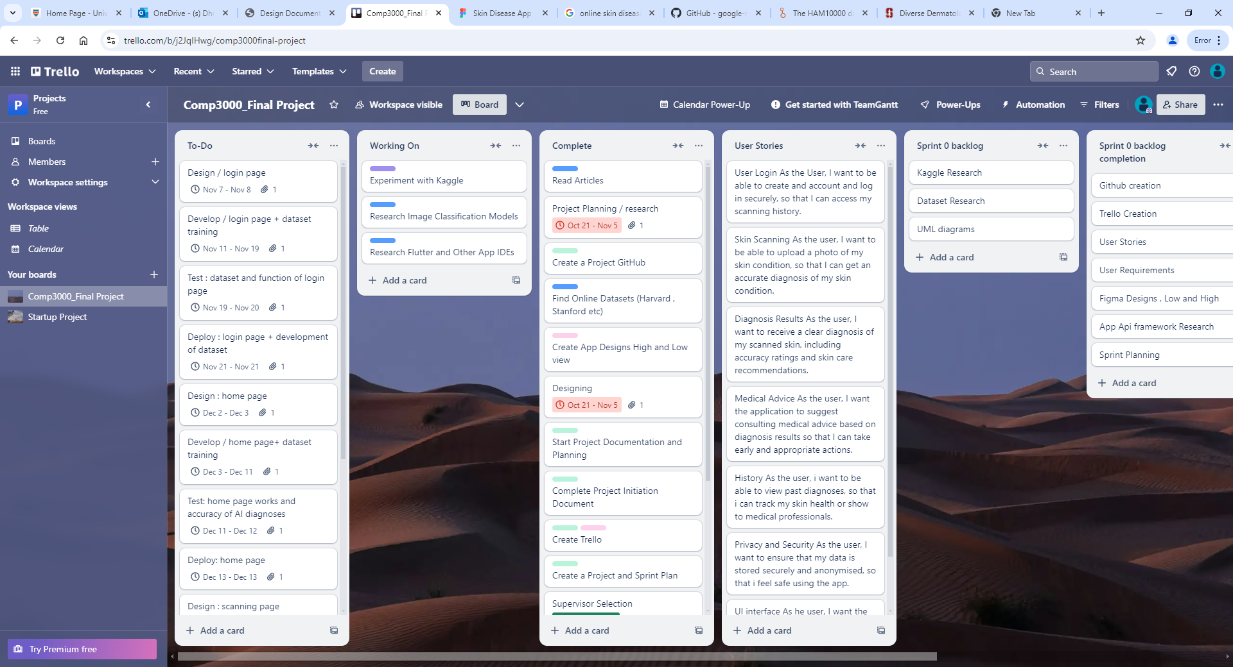

Kaggle Research

Image classification Models Research

Convolutional Neural Networks (CNNS)

IDEs and Frameworks

Android studio: Android studio is an IDE built for developing android applications, the software has a long history of updates making it reliable for developing an application.

Pros:

* Developed and Maintained by a reputable company
* Free software
* Long history of Updates and Support

Cons:

* Android development only
* Software/development is outdated
* Intensive Ram use

Flutter: Flutter is an open-source IDE developed by Google, it is used to develop applications for multiple platforms such as windows, android and IOS.

Pros

* Development for multiplatform
* Use of widgets creating smooth UI design
* Strong Community providing support
* Automated tool testing kit

Cons

* Large application size
* Limited support of third-party libraries

Dataset Research

Harvard: HAM10,000 dataset

<https://dataverse.harvard.edu/dataset.xhtml?persistentId=doi:10.7910/DVN/DBW86T>

Stanford Dataset: Diverse Dermatology images

<https://ddi-dataset.github.io/index.html#paper>

Google: SCIN Dataset

<https://github.com/google-research-datasets/scin>